Formatting Guide of North-Western Polytechnical University
Undergraduate Graduation Project (Thesis)
This is a guide of the formatting of graduation theses for undergraduate students of North-Western Polytechnical University. Students should follow the formatting guidelines to ensure a well-formatted paper in partial fulfillment of the graduation project.
In this guide, you will find guidelines about the formatting as listed below:

- General Rules
- Formatting Cover Sheet
- Acknowledgement
- Abstract
- Table of Contents
- Body of the Paper
- References
- Appendices

1. General Rules
Page Size | 8.5" by 11" (A4).
Margins | 1" on all four sides. Text left justified. Paragraphs indented 5-7 spaces.
Spacing | Double spaced throughout (including references).
Header | Running head flush left. Page number flush right.
Font | Times New Roman, 12 point.
Short quotation | Quotations less than 40 words should be incorporated into the text within double quotation marks (“text”).
Long quotation | Four lines or 40 words or more (block quotations), double-spaced block without quotation marks. Indent the entire quote 1/2 inch (generally, one tab). No indentation on the right side.
Sections | Each section of the paper (title page, abstract, body of paper, references, etc.) should begin on its own page. Use Insert>Page Break or CTRL+ENTER to divide your paper into sections.
Major heading | Centered, Boldface, Uppercase and Lower Case Heading
Subheading 1 | Flush Left, Boldface, Uppercase and Lower Case Heading
Subheading 2 | Indented, boldface, lowercase, with a period.
Subheading 3 | Indented, boldface, italicized, lowercase, with a period.
Subheading 4 | Indented, italicized, lowercase, with a period.

Note: In your thesis, you should include the following sections:
1. Cover Sheet
2. Acknowledgement (optional)
3. Abstract
4. Table of Contents
5. Body
6. Reference pages
7. Appendices (optional)
Guidelines 2-7 show you how each of these section is formatted.

2. Formatting Cover Sheet
Page Size: 8.5” by 11”, (A4)
Margin: 1 inch on all sides
Running Head

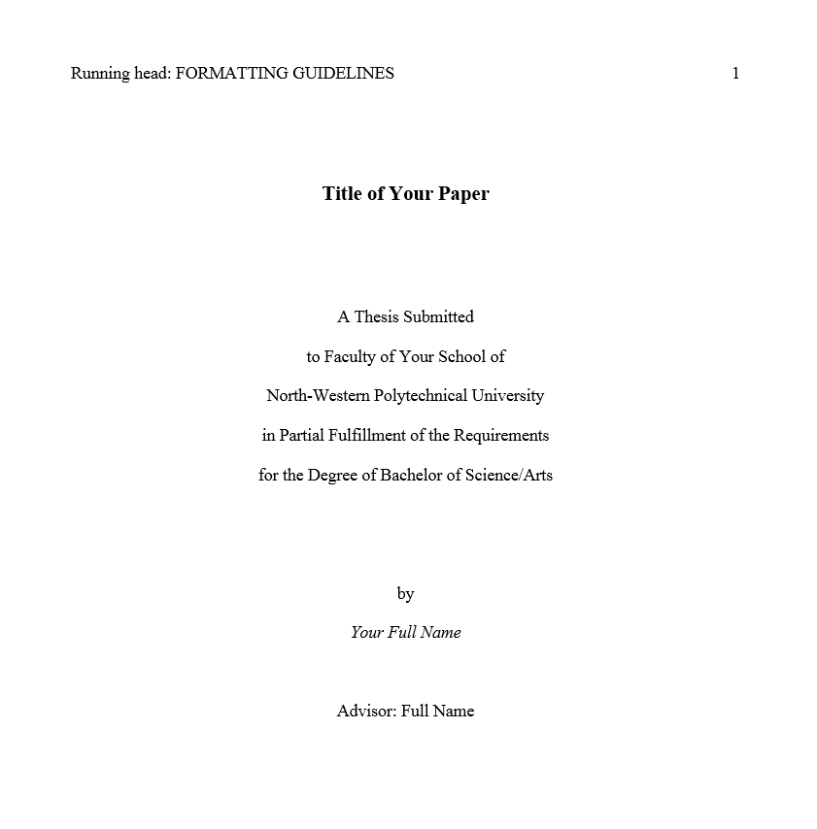
Page numbers, flush right
Times New Roman, 14 point
Spacing: Double-spaced
throughout

The running head is a reduced version of the full title of the paper
• Less than 50 characters
• Capitalized (Running head title only)
• Left-justified
• On the title page, include the words “Running head.” On all other pages, include the reduced title only

2. Acknowledgement (optional)
Content of your acknowledgement…
3. Abstract
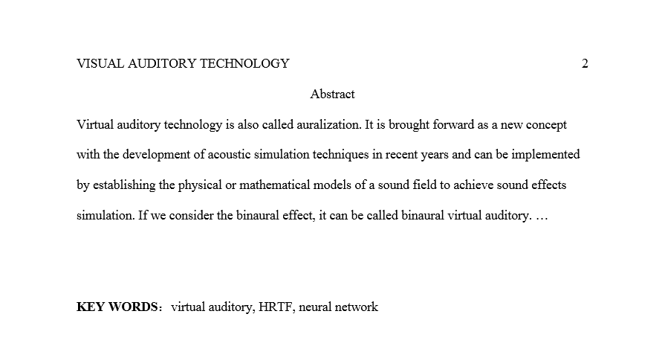
Capitalized, boldface, with a colon

Title | “Abstract” Centered, non-bold.
Paragraph | Single paragraph. Flush left. No indentation.
Purpose | Brief overview of the thesis and the main findings of the research. Should not repeat the thesis content word for word.
Length | 150 – 250 words.
Content | No quotations or citations.
Key words | 3-5, all in lower case (except for abbreviations)

4. Table of Contents
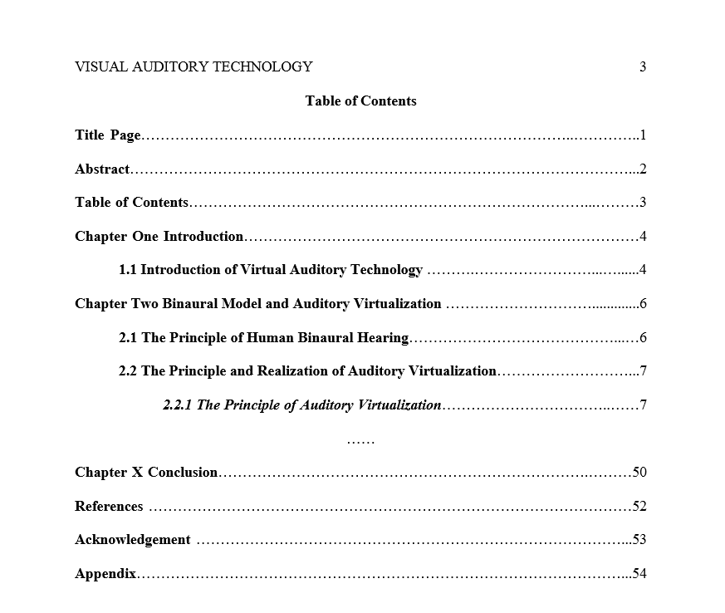
5. Body of the Paper

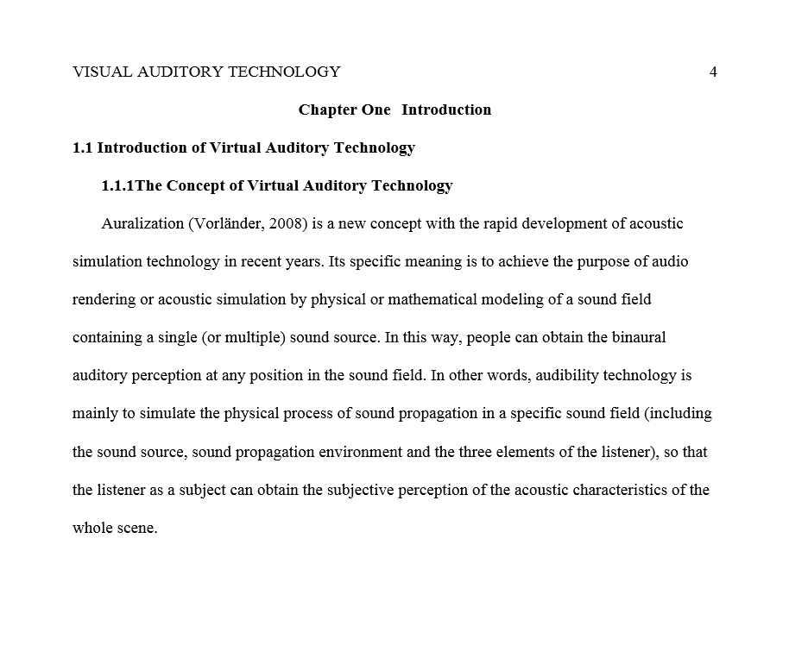
Works cited in brackets, (Last Name, year, page)

In-Text Citation Formatting Samples
Work by an author | (Boorstin, 1992, p. 2)
Work by two authors | (Cuppy & Steig, 1950, pp. 67-70)
Work by 3-5 authors | (Smit, Hopper, & Jones, 1998, p. 3) then subsequently  (Smit et al., 1998, pp. 13-27)
Work by 6+ authors | (Heinman et al., 2000, p. 10)
Work by organization | (American Psychology Association [APA], 2003, p. 3) then  subsequently (APA, 2003, p. 13)
No listed author (article) | (“Disney Retreats,” 1994, p. 49)
No listed author (book) | (College Bound Seniors, 2008, p. 212)

Formatting Formula


Formula should be centered and numbered on the right

Formatting Tables and Figures
Numbered with Arabic numerals.

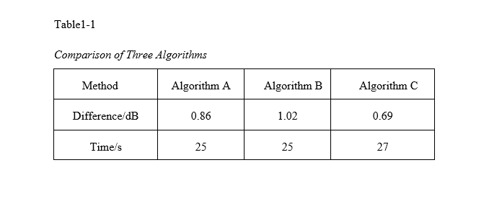
Title in italics below label
Numbered with Arabic numerals.

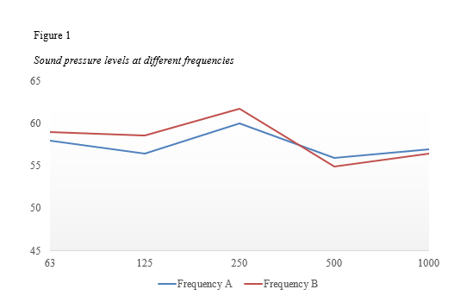
Title in italics below label

6. References
Common Entries in a Reference Page
Entries listed alphabetically, based on last name of the author or title of the reference. Double-spacing.
1. Book with One Author:
Last Name, First Name. Title of Work. City: Publisher, Date.
2. Book with Two or More Authors:
Last Name, First Name, and First Name Last Name. Title of Work. City: Publisher, Date.
Hanging indention by 5-7 spaces for lines after the first.
3. Journal Article:
Last Name, First Name. “Title of article.” Title of Journal. Volume Number. Issue Number (Date): Page Range.
4. Work in Anthology or Edited Collection:
Last Name, First Name. “Title of Chapter.” Title of Work. Ed. First Name Last Name. City: Publisher, Date. Page Range.
5. Entire Anthology or Edited Collection:
Last Name, First Name, ed. Title of work. City: Publisher, Date.
6. Book by a Corporate Author:
Corporate Author. Title of Work. City: Publisher, Date.
7. Article with No Author in Reference Book (familiar reference books, such as dictionaries or encyclopedias)
"Entry Name." Title of Work. Edition. Year.
8. Document from On-line Academic Journal:
Last Name, First Name. "Article's Name." Information about Print Version of Publication. Information about Electronic Version of Publication. Date of Access and URL of page (or of database's search page).

7. Appendices (optional)
Appendix A
Appendix B
…
Appendix X
1. For more than one appendix, the heading “Appendix” should be accompanied by capital letters A, B, C and so forth (e.g. Appendix A, Appendix B, Appendix C).

2. Indent the first line by 5-7 spaces.

